|  |  |
| --- | --- |
| e | CoE Starter Kit – Audit Log Connector |
|  |  |
|  | The Center of Excellence (CoE) starter kit is a collection of components and tools that are designed to help get started with developing a strategy for adopting and supporting the Power Platform, with a focus on Power Apps and Power Automate.  This document outlines how to set up a connector to the Office 365 Audit Log using authentication with a bearer token, which is required if your admin account has MFA enabled.  Download the most updated assets from the [**GitHub repository**](https://github.com/microsoft/powerapps-tools/tree/master/Administration/CoEStarterKit).  The entire content package can be downloaded directly at [**aka.ms/CoEStarterKitDownload**](https://aka.ms/CoEStarterKitDownload)  3/17/20 |

Contents

PreRequisites 3

Purpose of this Document 3

Create an azure app registration for the office 365 management api 3

Setup the custom connector 7

Setup the Power Automate Flow 10

## PreRequisites

The following are prerequisites for installing the CoE starter kit as it comes in the solution.

1. **Admin account**Either Global Admin access or explicit access to the audit logs (configured in the Exchange Admin Center)
2. **CoE Starter Kit – Core Components Solution**  
   The CoE Core Components solution must be installed already. Please see <https://github.com/microsoft/powerapps-tools/tree/master/Administration/CoEStarterKit> for Setup Instructions of the CoE Starter Kit.
3. **Download the CenterofExcellenceAuditLogs_1_0_0_7_managed.zip from GitHub**

## Purpose of this Document

The [regular setup instructions](https://github.com/microsoft/powerapps-tools/tree/master/Administration/CoEStarterKit) outline how to connect to the Office 365 Audit Log using basic authentication. The purpose of this document is to help you set up a custom connector to the Office 365 Audit Log that works if your Admin Account has MFA enabled or if you can’t use basic auth to connect to the Office 365 Audit Log.

The steps involved are creating an Azure App Registration, setting up a custom connector and configuring a flow.

## Create an azure app registration for the office 365 management api

In this document, we will focus on setting up an Azure AD App Registration that can be used in a custom connector and Power Automate flow to connect to the Office 365 Audit Log. For additional information on the Office 365 Management API, please see the [following article on docs.microsoft.com](https://docs.microsoft.com/en-us/office/office-365-management-api/get-started-with-office-365-management-apis).

Create an Azure App Registration for the **Office 365 Management API**

1. Login to Azure (<https://portal.azure.com>)
2. Navigate to Azure Active Directory / App Registrations  
   A screenshot of a social media post

   Description automatically generated
3. Create a new registration  
   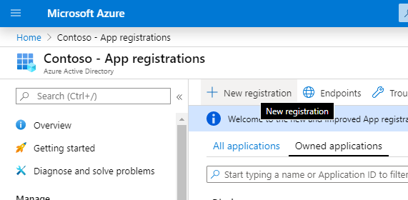
4. Provide a name (e.g., “Office 365 Management”), don’t change any of the other settings and click **Register**  
   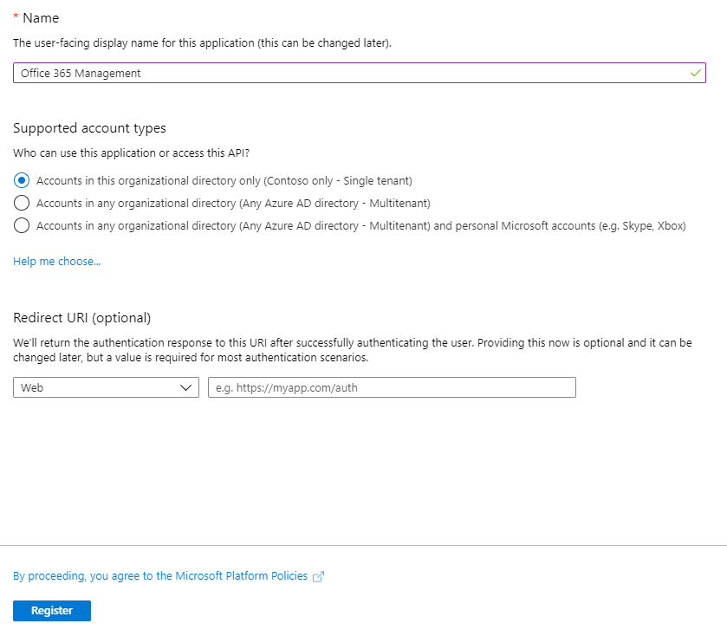
5. Configure **API Permissions**
   1. Select API Permissions > + Add a permission  
      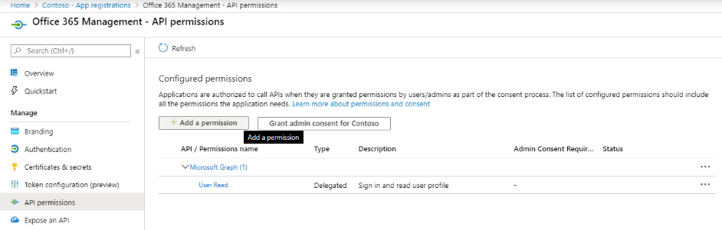
   2. Select Office 365 Management API  
      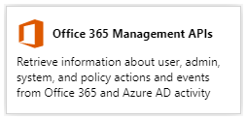
   3. Set permissions:
      1. Click on **Delegated Permissions** and select **ActivityFeed.Read**   
         A screenshot of a cell phone

         Description automatically generated
      2. Click on Application permissions and select ActivityFeed.Read and ServiceHealth.Read  
         A screenshot of a cell phone

         Description automatically generated
      3. Click Add permissions
   4. The API Permissions should look like the below. 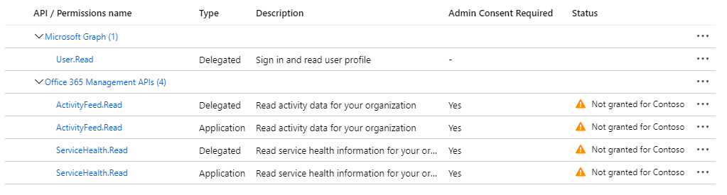
   5. Select Grant Admin Consent for (your organization)  
      
   6. The API Permissions should now look like the below.  
      A screenshot of a cell phone

      Description automatically generated
6. Client secret
   1. Click on Certificates and Secrets  
      
   2. Select + New Client Secret  
      A screenshot of a cell phone

      Description automatically generated
   3. Add a description and expiration (in line with your company policies) and click Add  
      A close up of a logo

      Description automatically generated
   4. Copy the Secret to Notepad for the time being  
      
7. Copy values needed for authentication of the custom connector
   1. Click on overview  
      
   2. Copy the Application (client) id and Directory (tenant) id values to the same notepad, make sure to take note of which GUID is for which value  
      
   3. You will need these values in the next step as we configure the Custom Connector.
8. Leave the Azure AD Portal open, as we will need to make some configuration updates after setting up the custom connector.

## Setup the custom connector

We will now configure and set up a custom connector that uses the Office 365 Management APIs  
<https://docs.microsoft.com/en-us/office/office-365-management-api/get-started-with-office-365-management-apis>

1. Navigate to make.powerapps.com
2. Import the new **Center of Excellence – Audit Logs** solution, which contains the custom connector and Power Automate flow to sync audit logs to CoE CDS entities.
3. Open the solution, click on the **Office 365 Management API custom connector** and click on edit   
   A screenshot of a social media post

   Description automatically generated
4. **Custom connector** setup:
   1. Leave the 1. General page as is and click **Security 🡪**   
      A screenshot of a cell phone

      Description automatically generated
   2. Click on **Edit** at the bottom of the OAuth 2.0 area to edit the authentication parameters   
      A screenshot of a cell phone

      Description automatically generated
   3. Paste the Application (Client) ID you have copied from the App Registration under Client Id  
      Remember, this is the value you copied from the Overview   
      
   4. Paste the Client Secret you have copied from the App Registration under Client Secret  
      Remember, this is the value you copied from Certificates & Secrets  
      
   5. Leave the Tenant ID to common
   6. Set the Resource URL to **https://manage.office.com**
   7. Copy the Redirect URL into your Notepad   
      A screenshot of a cell phone

      Description automatically generated
   8. Click **Update Connector**  
      
5. Update **Azure AD App Registration with the Redirect URL**
   1. Go back to the Azure AD Portal and your App Registrations
   2. Under Overview, click on Add a Redirect URI  
      
   3. Select + Add a platform  
      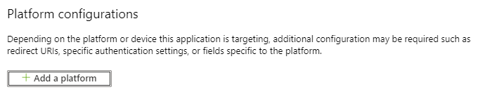
   4. Choose Web  
      A screenshot of a social media post

      Description automatically generated
   5. Enter the URL you have copied from the Redirect URL section of the Custom Connector (step 9.g above)
   6. Click Configure
6. Go back to the Custom Connector setup to set up a connection to the Custom Connector and Start a Subscription to the Audit Log Content (<https://docs.microsoft.com/en-us/office/office-365-management-api/office-365-management-activity-api-reference#start-a-subscription>).   
   It is important to complete these steps for the flow to work.
   1. Select Test  
      
   2. Create a **+ New connection** and login to the user account with access to the audit logs
   3. Select **StartSubscription** as Operation  
      A screenshot of a cell phone

      Description automatically generated
   4. Copy the Directory (Tenant ID) under **tenant** and **PublisherIdentifier**  
      Remember, this is the value you copied from the Overview of the Azure App Registration  
      
   5. Click **Test Operation**
   6. You should see a (200) Status returned, which means the query was successful  
      A screenshot of a social media post

      Description automatically generated  
      Note: If you do not see a (200) response, the request has failed and there is an error with your setup. The flow will therefore not work.

## Setup the Power Automate Flow

A Power Automate flow queries the Audit Log daily and writes the Power Apps Launch Events to a CDS entity, which is then used in the Power BI Dashboard to report on sessions and unique users of an app.

The final step is to configure the Power Automate flows.

1. Navigate to **make.powerapps.com**
2. Open the Center of Excellence – Audit Log solution and edit the **Admin | Sync Audit Logs** (Click on the Flow in the solution to open it in the maker portal, and then click on edit there. You will not be able to select Edit directly from the solution.)
3. Paste in the ID you have copied from Directory (tenant) ID  
   Remember, this is the value you coped from Directory (tenant) ID from the App Registration Overview  
     
   A screenshot of a cell phone

   Description automatically generated
4. Optionally update the time interval at which the log clusters should be retrieved. Default is set to 1 day intervals (from Month, Week, Day, Hour, Minute, Second)  
   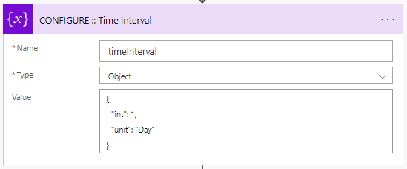
5. Optionally update the start time and end time at which the logs will read from.   
   The maximum is 7 days in the past, and the end time must be after the start time (a smaller amount of time subtracted in the action). Use a positive number in the interval field.  
   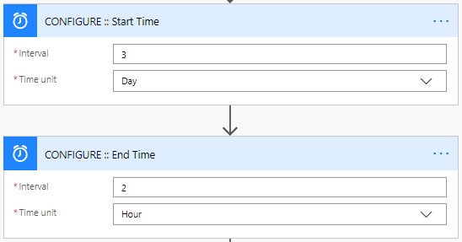
6. Go back to the Center of Excellence - Audit Log solution, open the flow details screen of the [Child] Admin | Sync Logs by clicking on its display name
7. Edit the **Run only users** settings  
   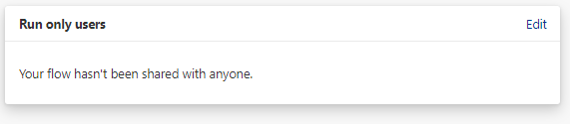
8. For both connections (Custom connector and Common Data Service), change the dropdown value to ‘Use this connection (userPrincipalName@company.com)’.   
   If there is no connection for any of the connectors, go to Data > Connections and create one for the connector.  
   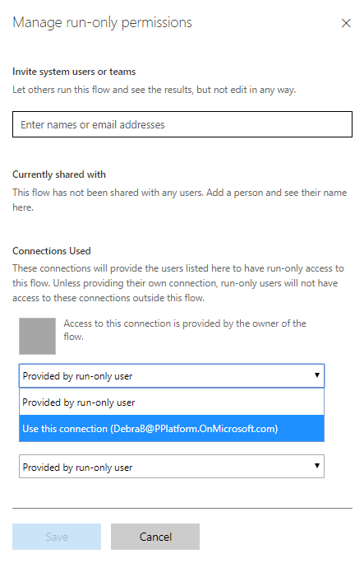
9. Click okay on the prompt
10. Click **Save** and close the Flow details tab
11. Click **Turn on** in the top navigation to turn on the Child Flow  
    A screenshot of a social media post

    Description automatically generated
12. Check the status changes to On  
    
13. Go back to the Center of Excellence – Audit Log solution, click on the **Admin | Sync Audit Log**s to open the flow details page and **Turn on** this flow as well.  
    A screenshot of a cell phone

    Description automatically generated